A Project Report On

**" Let’s Clean ( Waste Management ) "**

Submitted To

**MES Garware College of Commerce and**

**Savitribai Phule Pune University**

In partial fulfilment of the degree of

**Bachelor of Business Administration - Computer Application**



By

**Pratyush Majumdar**

**and**

**Mahendra Jat**

Seat No: **15429**

**and**

Seat No: **15422**

BBA-CA

Semester V

Under the guidance of

**Mrs. Padma Nene**

Research Guide

MES Garware College of Commerce, Autonomous, Karve Road, Deccan  
 Gymkhana, Pune – 411004 (2023-2024)



Maharashtra Education society’s

**GARWARE COLLEGE OF COMMERCE, AUTONOMOUS**

Karve Road, Deccan Gymkhana,

Pune - 411004

**CERTIFICATE**

This is to certify that Mr. **Pratyush Prakash Majumdar** and Mr. **Mahendra Devaram Jat** Roll Number **15429** and **15422** University Exam Seat Number ----- Students of BBA-CA Semester-**V** have successfully completed the project work in specialization subject **HTML, CSS, JS, PHP, MySQL and Bootstrap** entitled as **Let’s Clean   
( Waste Management )**  a partial fulfillment of the degree of Bachelors of Business Administration Computer Application as per the syllabus of Garware College of Commerce and Savitribai Phule Pune University for Year 2023-2024.

I further clarify that the work has been carried out under my supervision.

Project Guide BBA Coordinator Principal

Examiner External Examiner

**CONTENT**

|  |
| --- |
| 1. Introduction  * Introduction of System * Objective of System |
| 1. Requirements  * Hardware and Software Requirements |
| 1. System Design  * Entity Relationship Diagram * Context Level Diagram |
| 1. Website Design  * Homepage * E-waste Products * Paper Products * Cart * Upload Products * About Us     Backend   * Subscription and Contact Table * Product and Subscription data * Feedback and Login data |
| 1. System Limitations |
| 1. Conclusion |
| 1. References |

**INTRODUCTION OF SYSTEM**

* Our platform is dedicated to making a positive impact on the environment through effective waste collection and recycling practices.
* At Let's Clean, we prioritize responsible and sustainable waste management.
* Community engagement is at the heart of our service.
* We actively collaborate with local communities, educational institutions, and businesses to raise awareness about waste management and the importance of recycling.

**OBJECTIVES OF SYSTEM**

* The objective of our website is to create a platform that encourages and facilitates the collection and recycling of e-waste, paper, plastic and cloth materials.
* Our aim is to promote environmental sustainability by providing a convenient and efficient way for individuals to recycle these items, reducing the negative impact on the environment.
* Our aim is not just to collect waste but also to educate and inspire change.
* By facilitating the proper disposal of e-waste, the platform can create economic opportunities by connecting refurbishers and recyclers with potential customers.

**SYSTEM REQUIREMENT SPECIFICATION**

1. **HARDWARE REQUIREMENT**

* Internet connection or wireless adapter (Wi-Fi)
* Processor: Intel i3
* Memory(RAM): 4GB

1. **SOFTWARE REQUIREMENT**

* Operating System : Windows 10.
* Application Software : HTML, CSS, JavaScript, PHP, MySQL and Bootstrap.
* Browser : Google Chrome

**SYSTEM DESIGN**

1. **ENTITY RELATIONSHIP DIAGRAM**



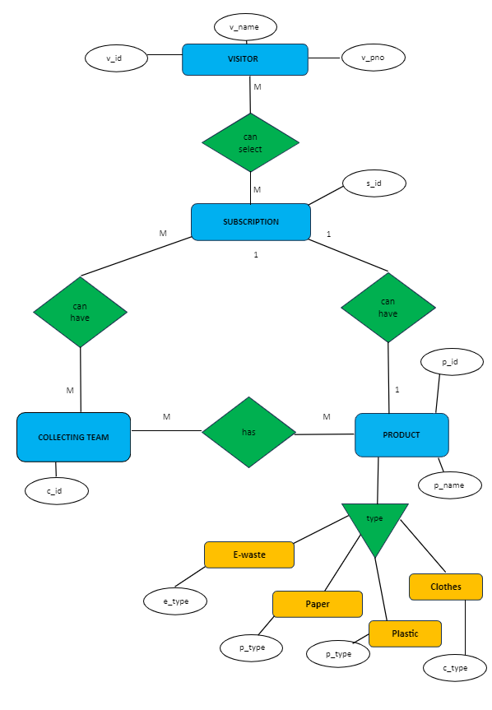

1. **CONTEXT LEVEL DIAGRAM**

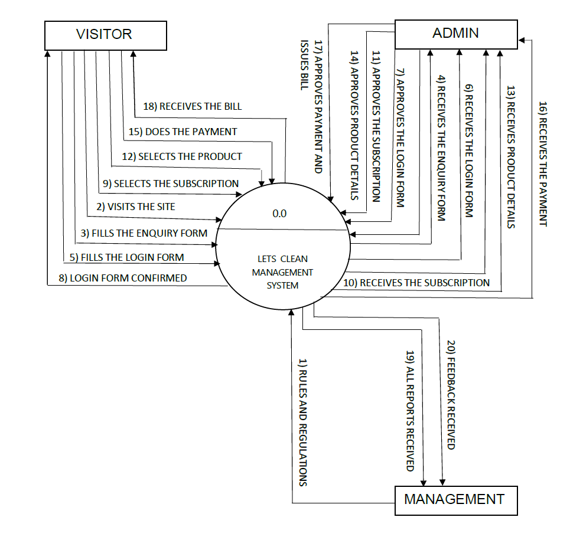

**SNAPSHOTS**

1. **HOMEPAGE**

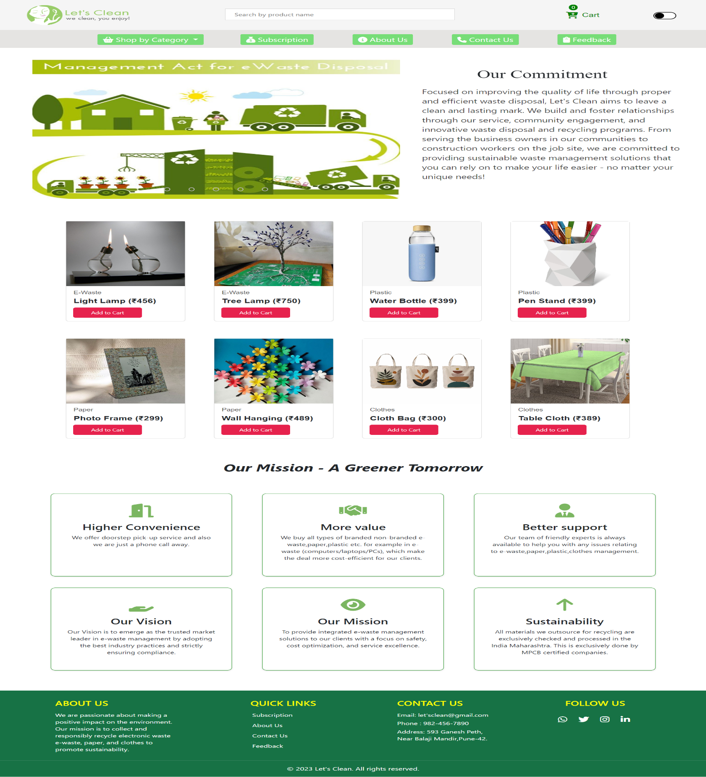

1. **E-WASTE PRODUCTS**

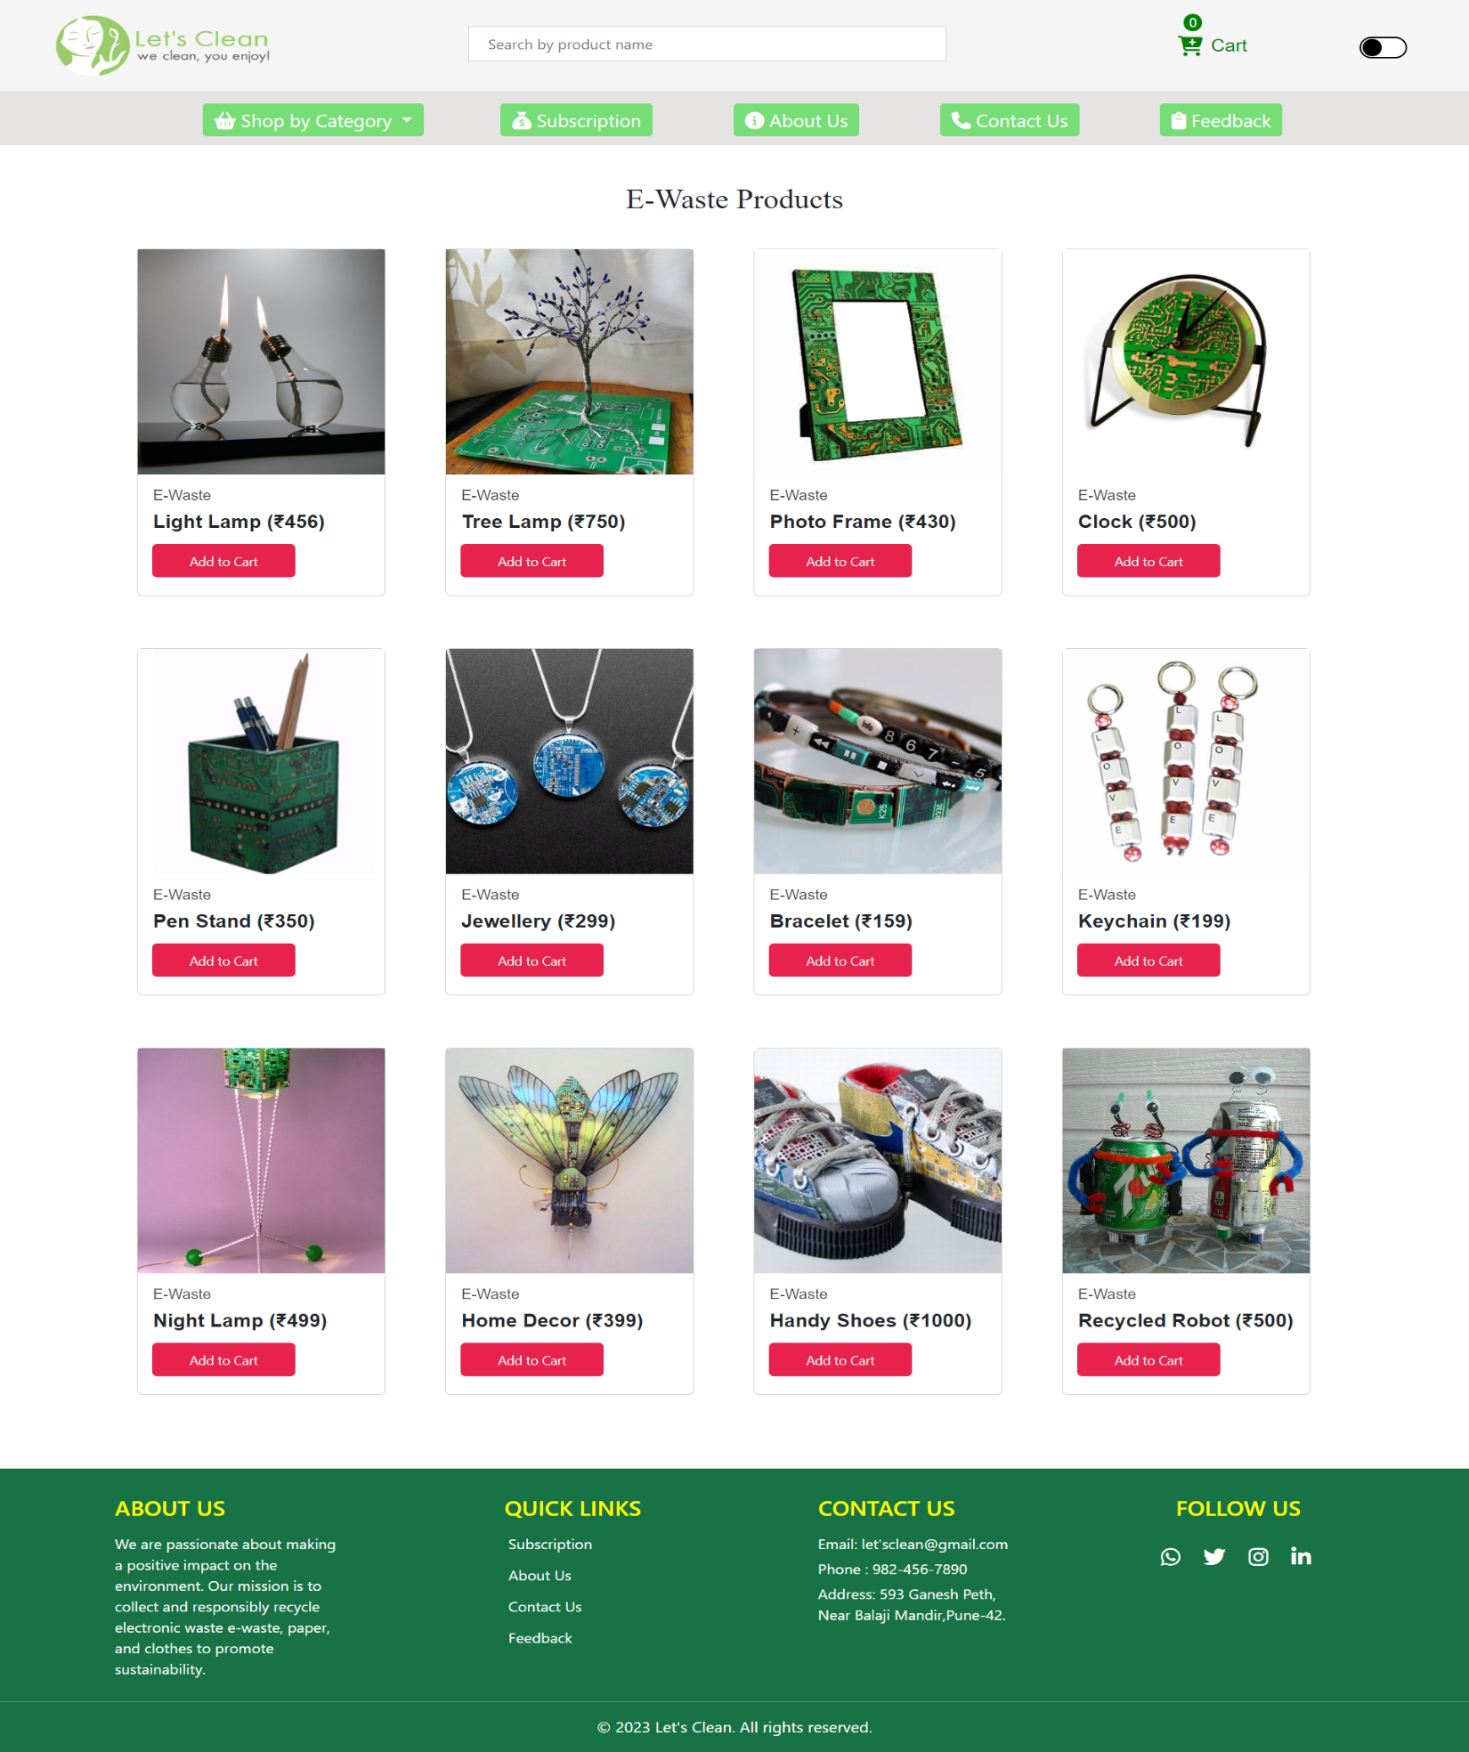

1. **PAPER PRODUCTS**

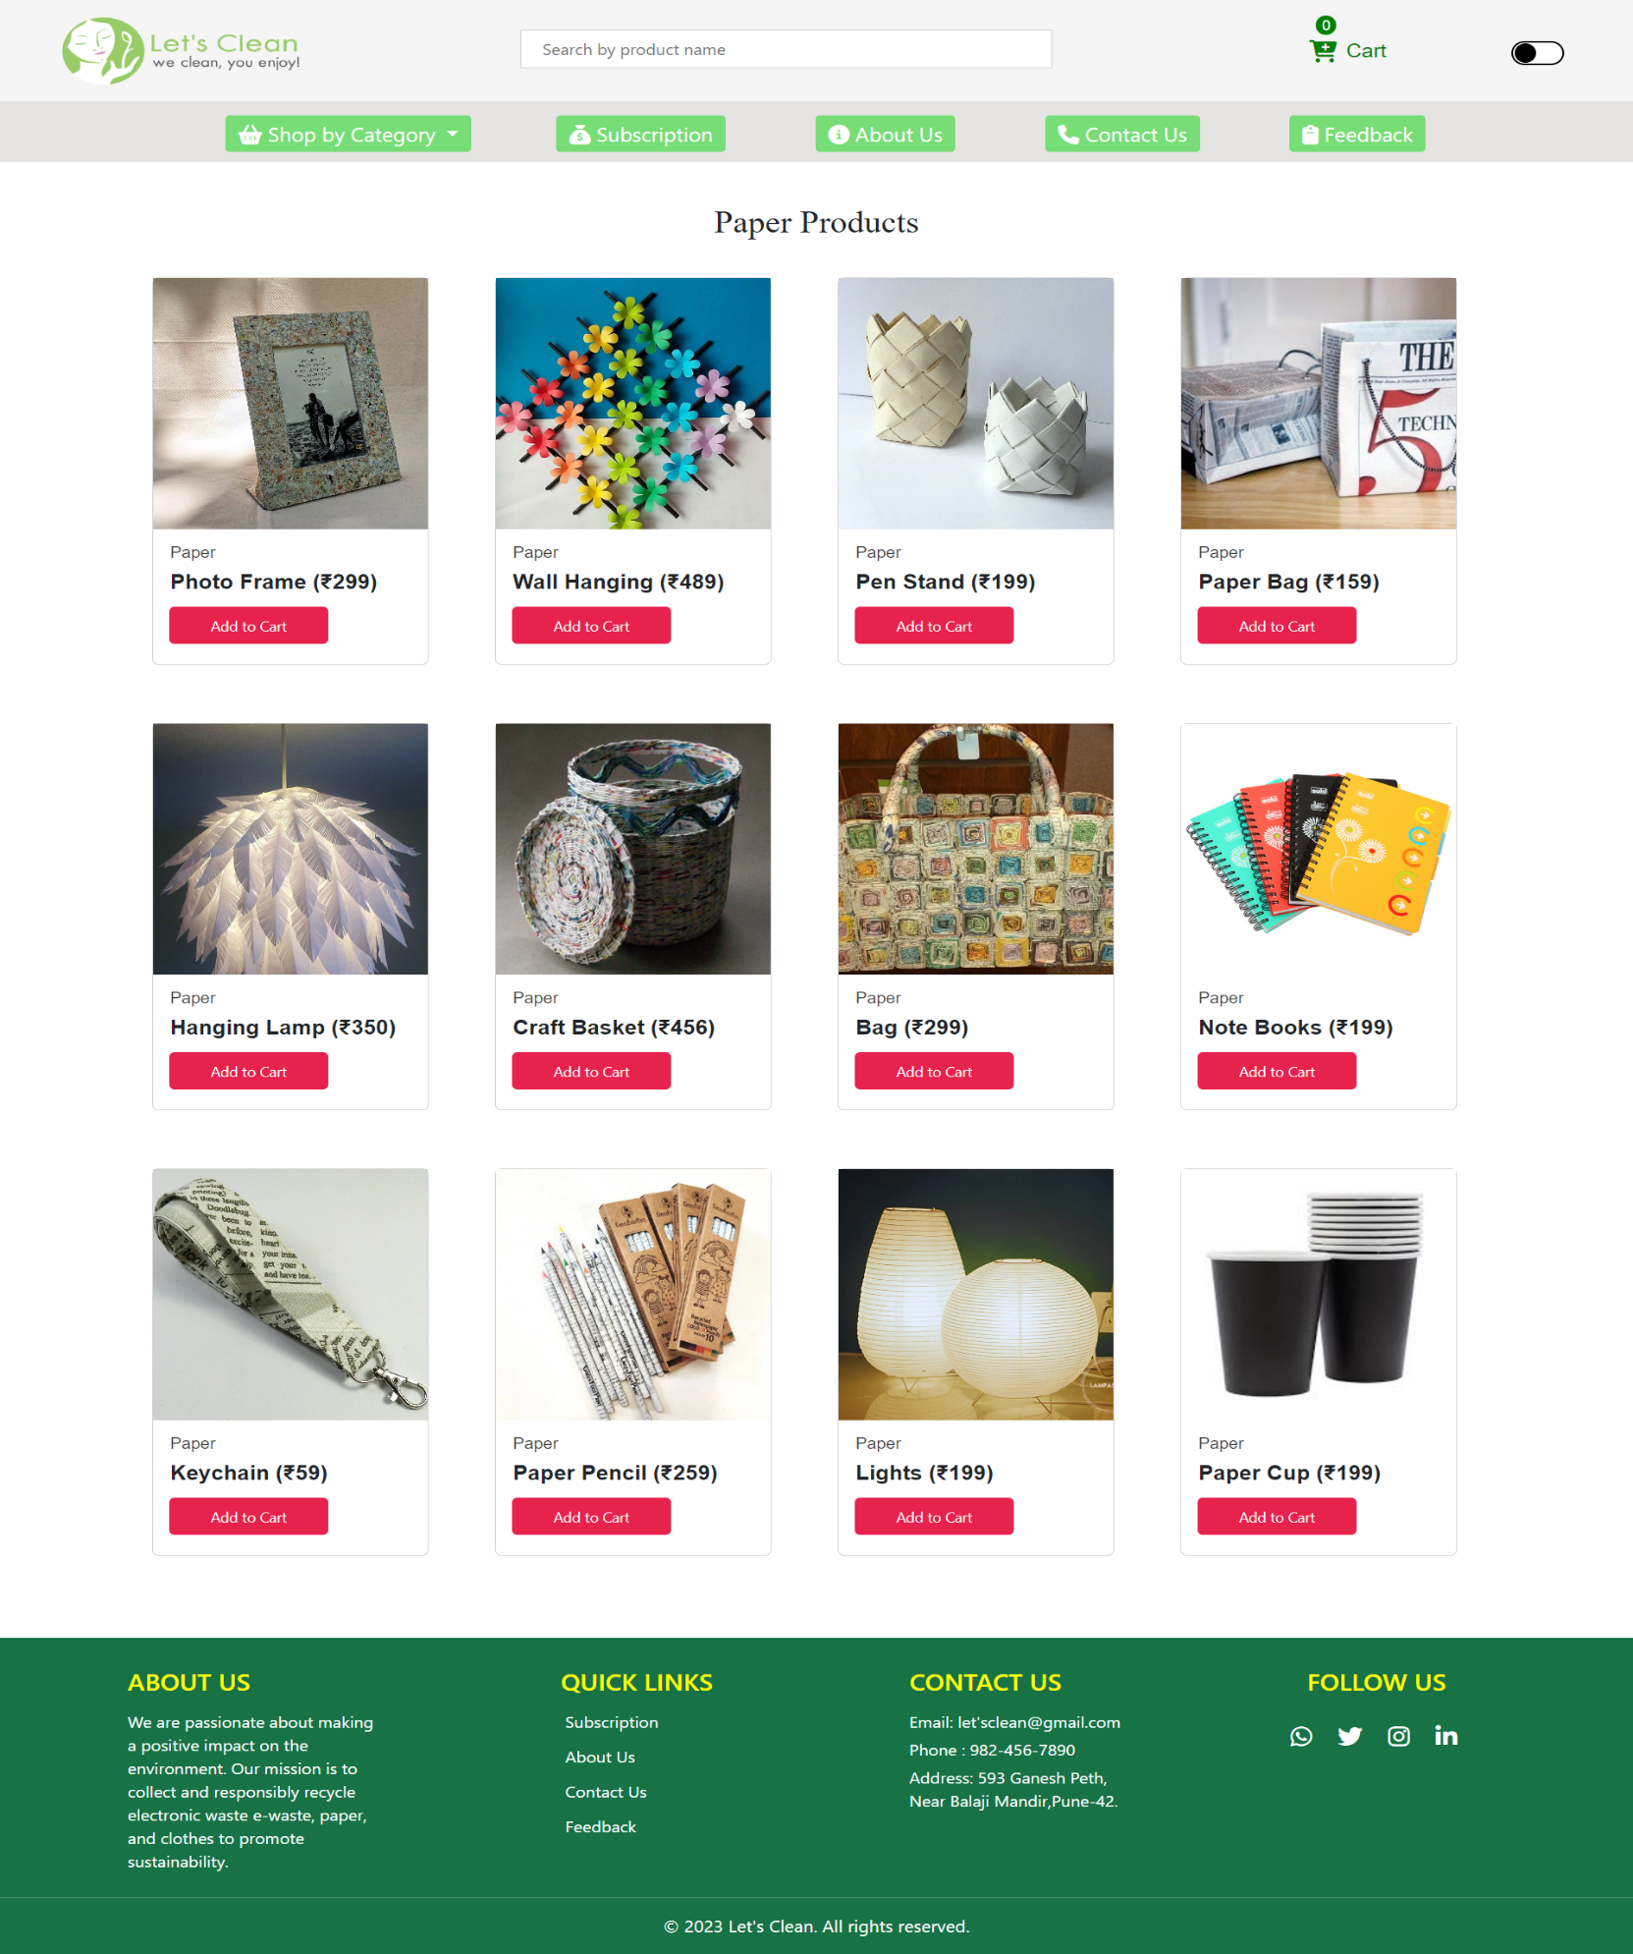

1. **CART**

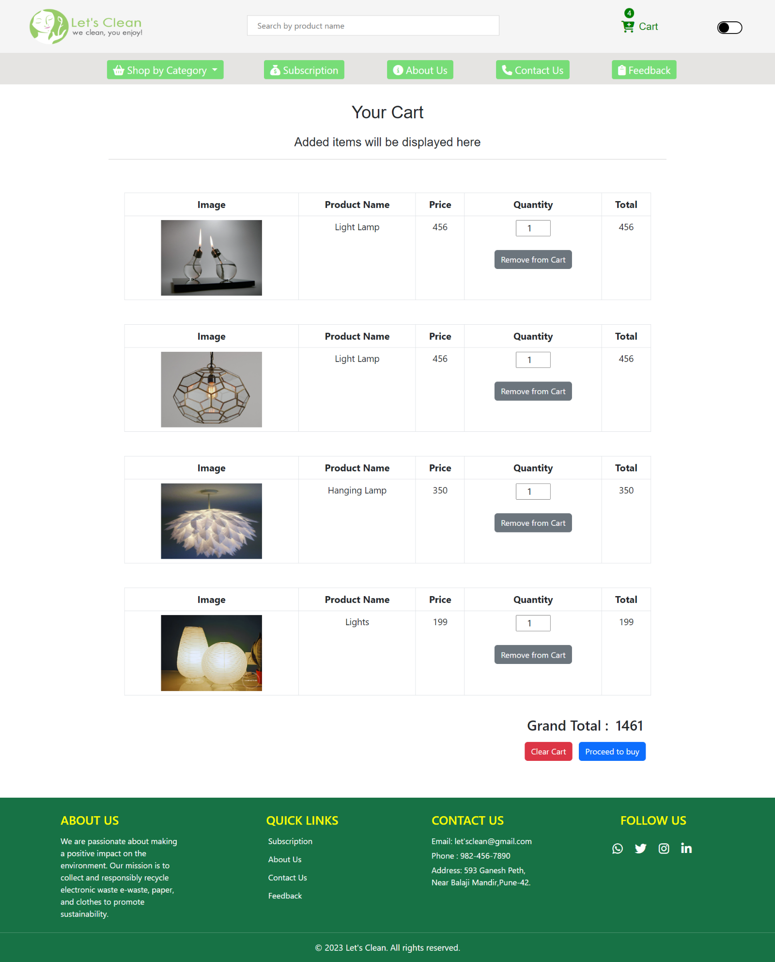

1. **UPLOAD PRODUCTS**

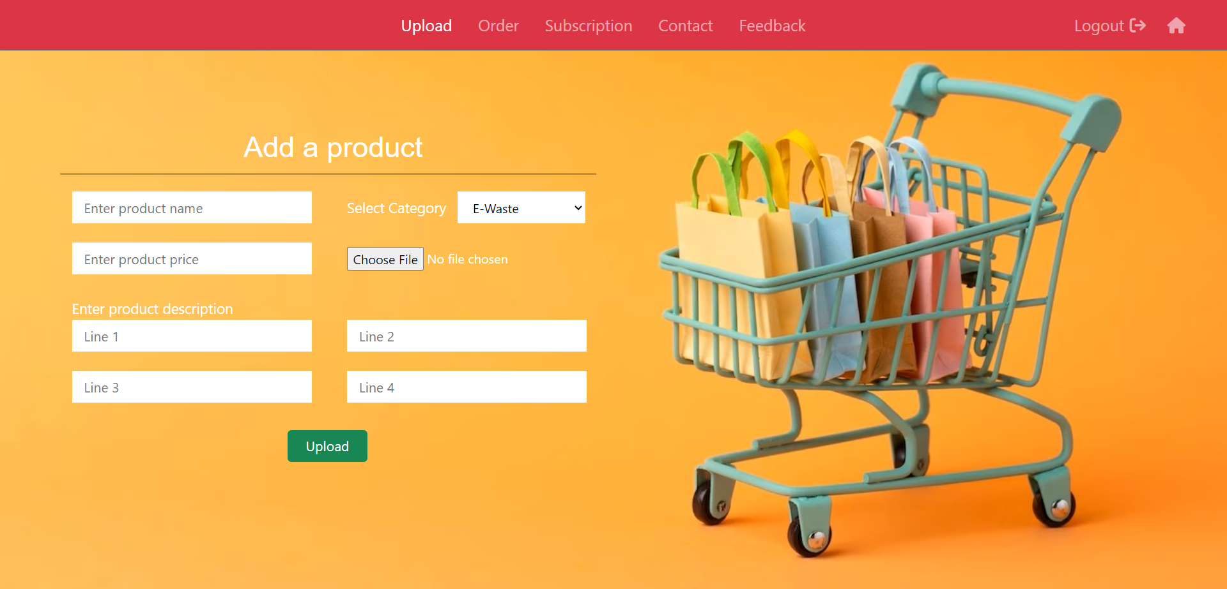

1. **ABOUT US**

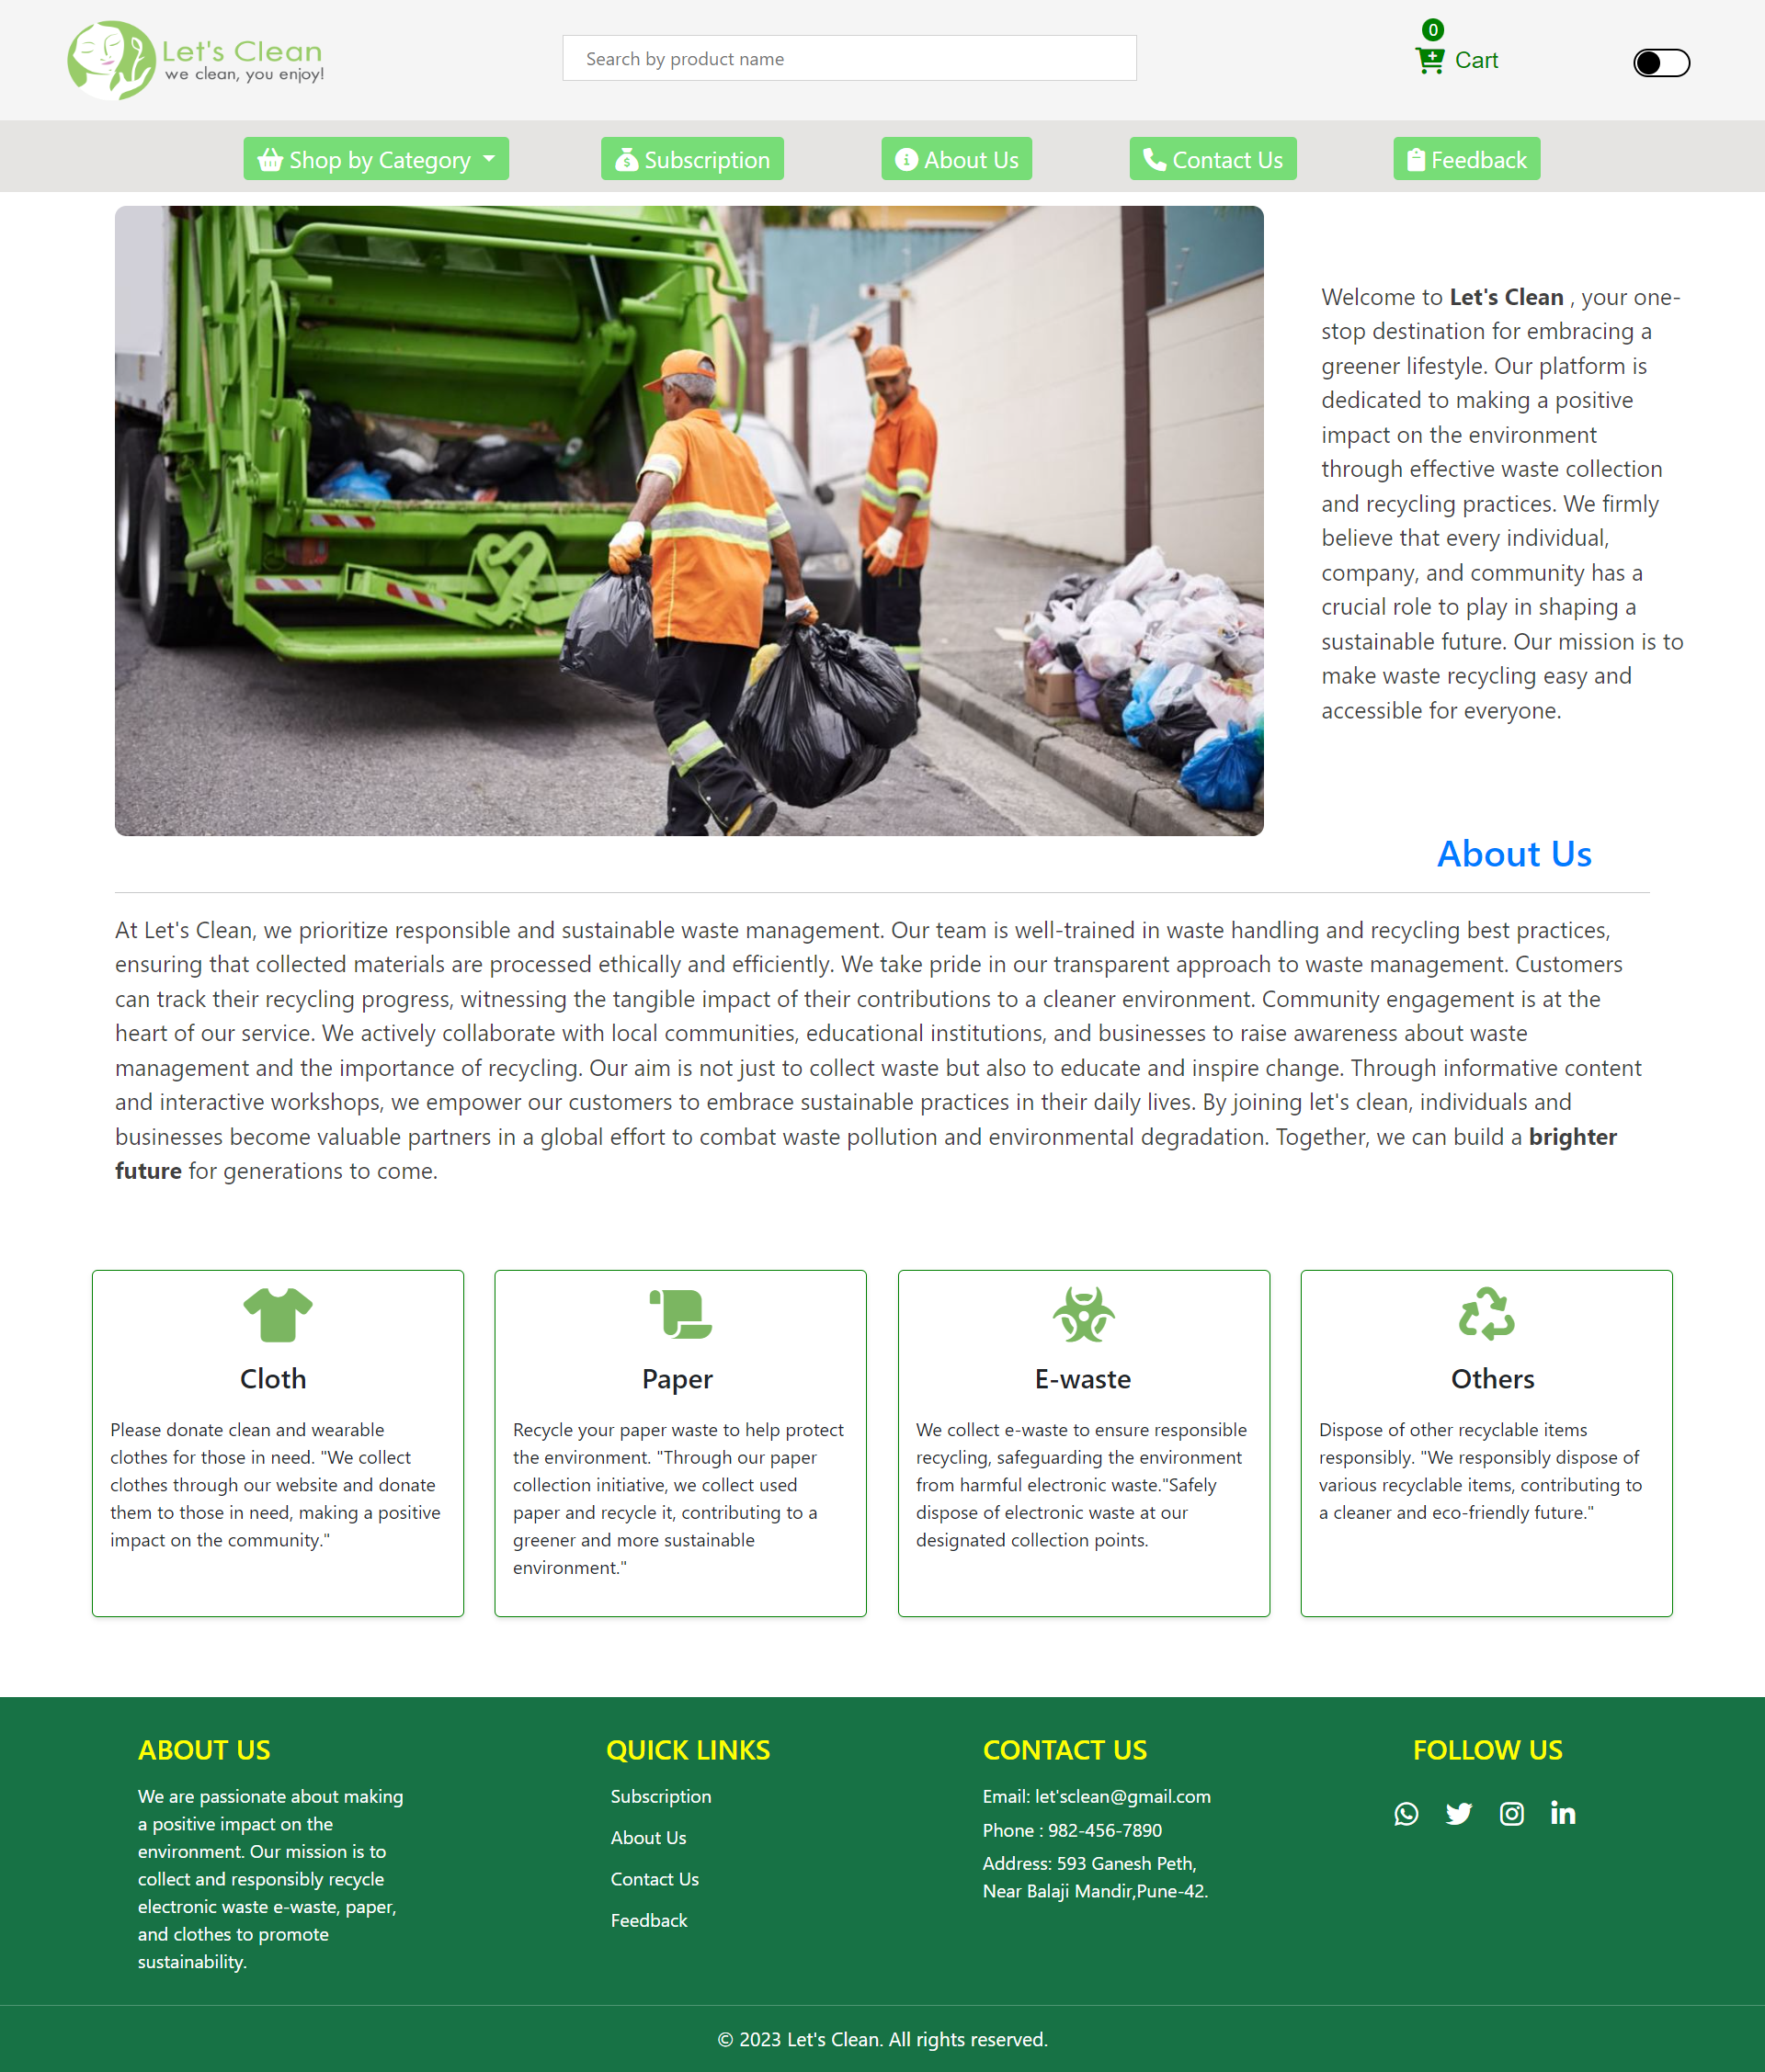

1. **SUBSCRIPTION AND CONTACT TABLE**

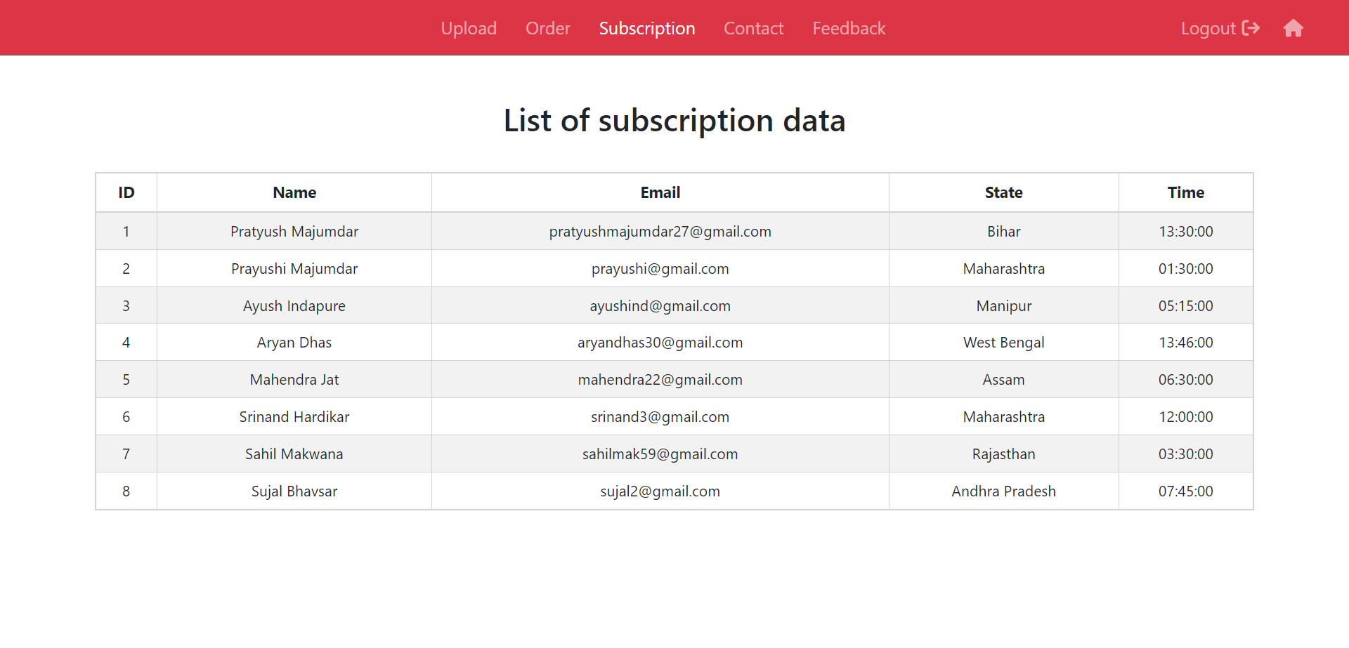

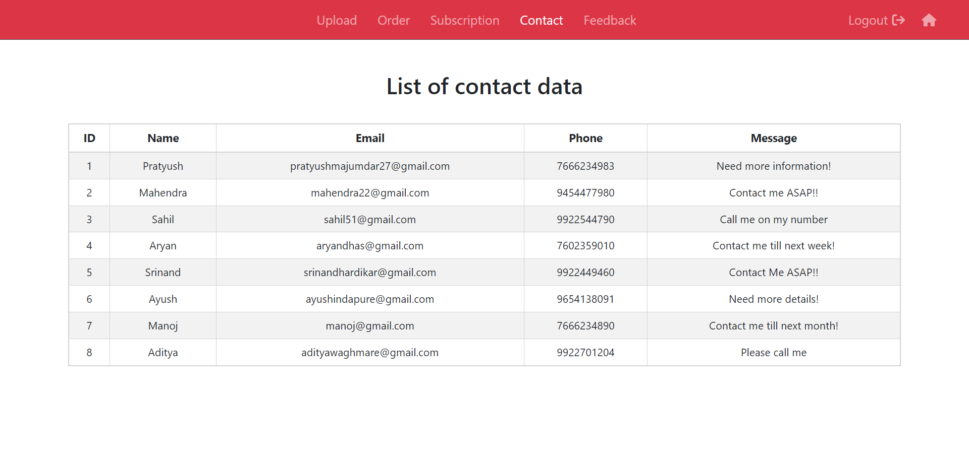

1. **PRODUCTS AND SUBSCRIPTION DATA**

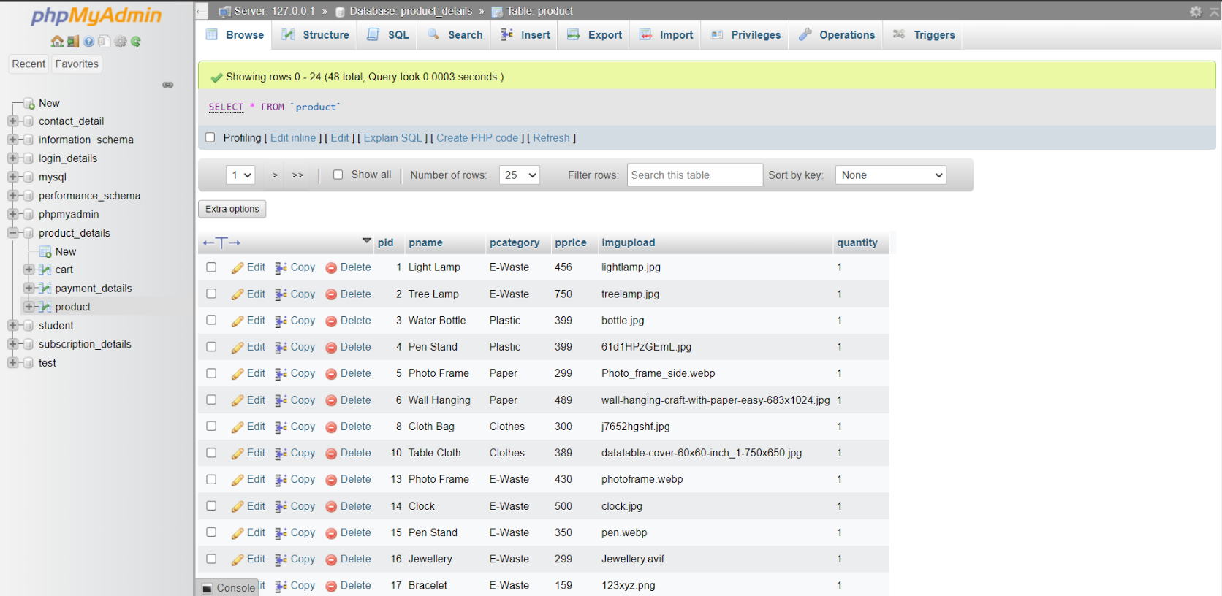

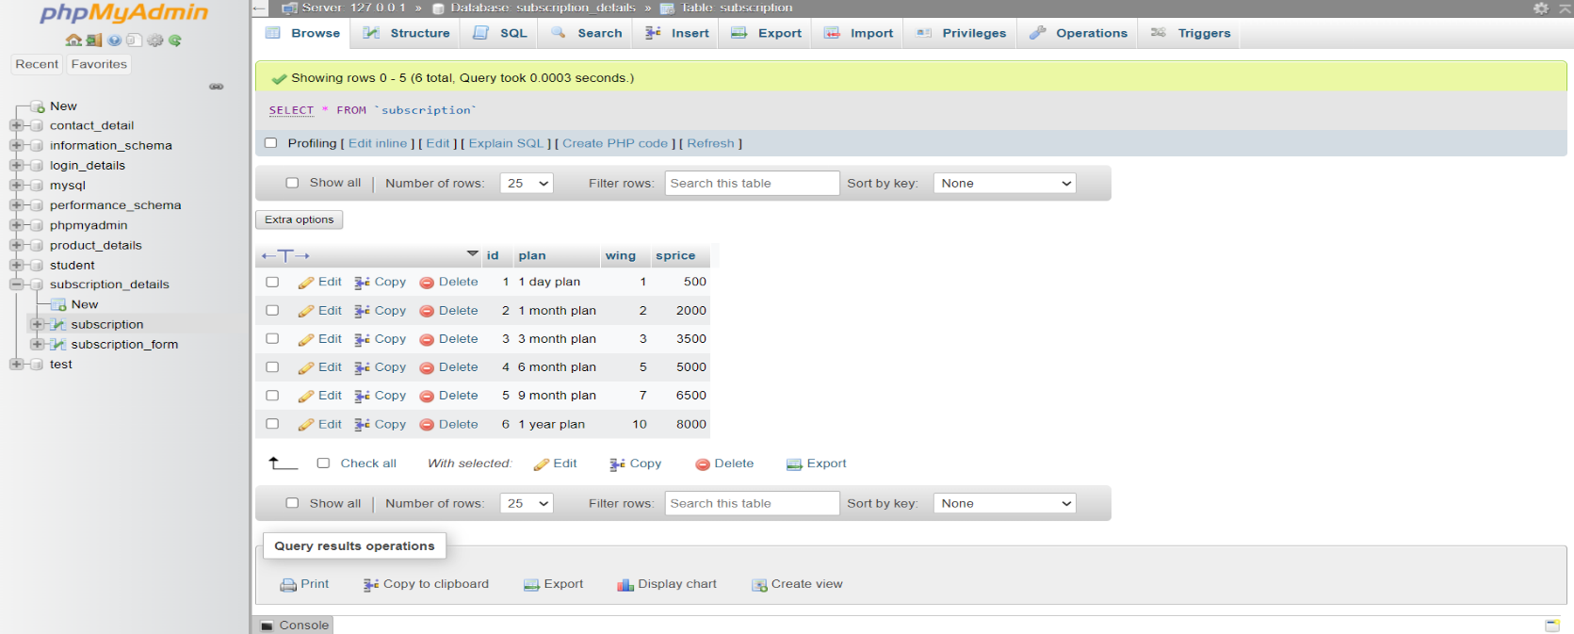

**9) FEEDBACK AND LOGIN DATA**

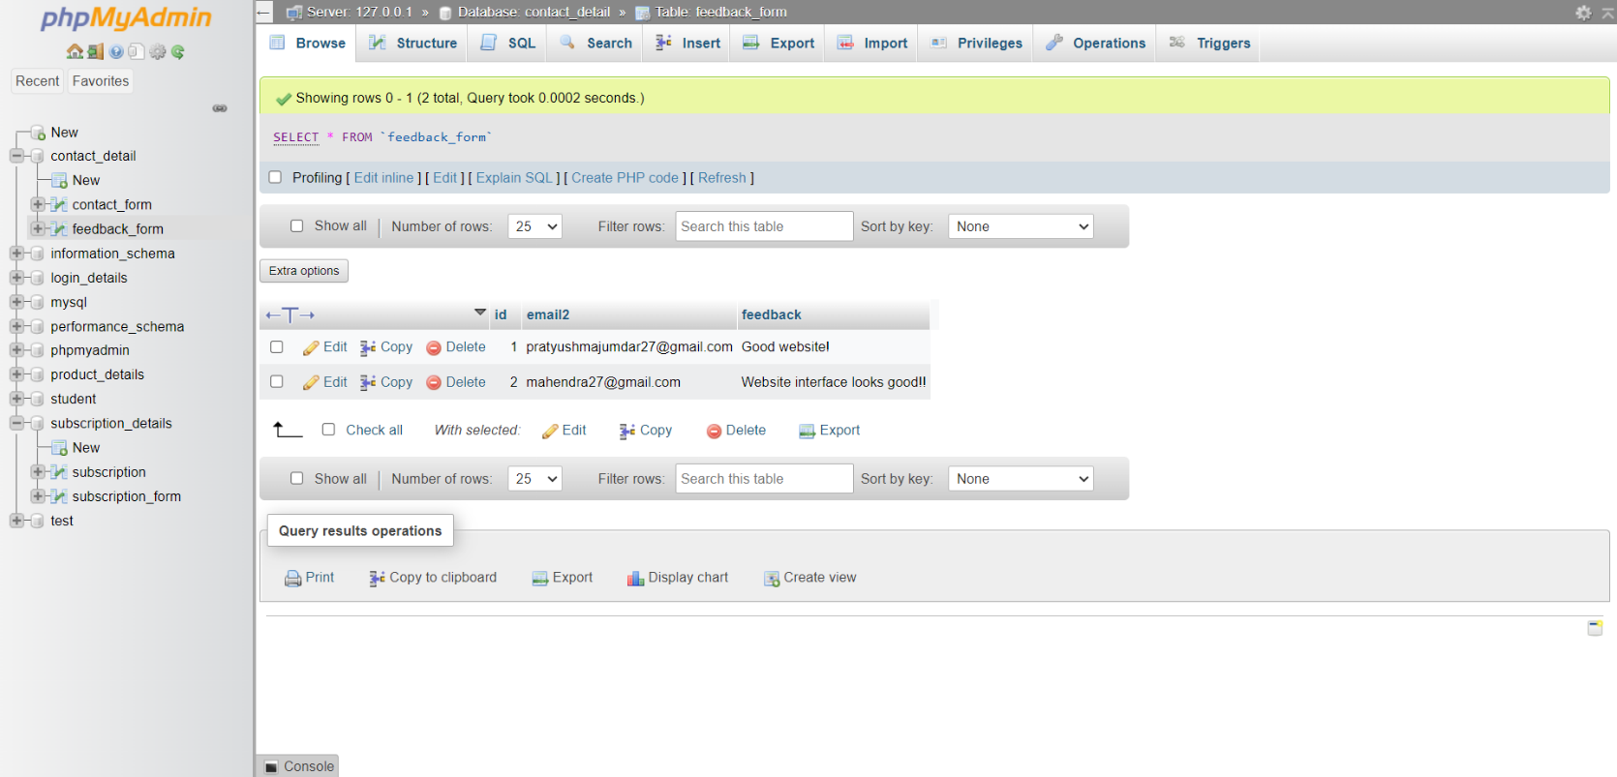

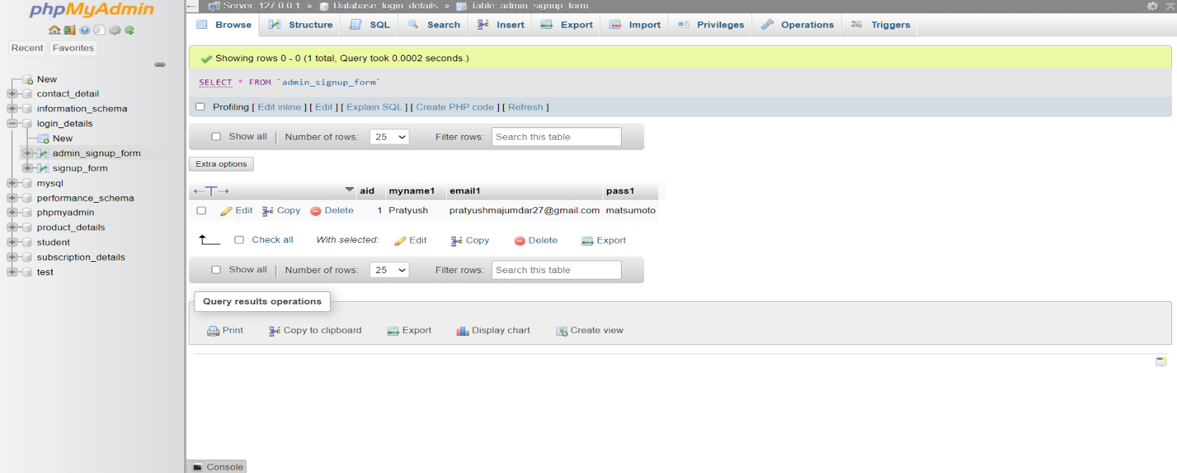

**SYSTEM LIMITATIONS**

* Waste management services are typically localized, so the services are only available in specific regions. Users from outside those areas may find the website irrelevant.
* Weather conditions, natural disasters, or other environmental factors can disrupt waste collection schedules, and the website may not always reflect these changes in real-time.
* Keeping the website up to date with changing regulations, schedules, and user needs is an ongoing challenge that requires dedicated resources.

**CONCLUSION**

* The website serves as a valuable tool for raising awareness about the importance of   
  e-waste management and educating users on the proper disposal methods.
* The website's accessibility and information may lead to a reduction in illegal disposal practices, such as dumping e-waste in landfills or improper disposal in the environment.
* By facilitating the location of e-waste recycling centers and drop-off points, the website encourages users to recycle their old electronics, contributing to resource conservation and reduced electronic waste.
* Over time, the website's efforts in promoting responsible e-waste disposal can lead to a reduction in the environmental impact of electronic waste, including reduced pollution and resource depletion.

**REFERENCES**

1. [https](https://www.farmingindia.in/) ://www.zolopik.com